Generating Fleet Available Capacity Simulator
Monte Carlo • Capacity VaR & Expected Shortfall • CLT in Power Systems

Problem Statement
Power-system reliability analysis requires the probability distribution of the total available capacity of a fleet of generating units. Each unit can be in one of several discrete capacity states (forced outage, partial derating, or full output). Analytic convolution rapidly becomes intractable. Monte Carlo simulation of many independent fleet scenarios is the industrial standard method for obtaining the capacity distribution, low-tail risk metrics and Loss-of-Load style probabilities.

Solution Strategy
1. Core pure-Python loop that mirrors the original book (pre-filled dict + progress every second).
2. Two production-style alternates – collections.Counter and a fully vectorized NumPy implementation.
3. Exact theoretical PMF via the classic dynamic-programming recurrence (benchmark for sampling error).
4. Low-tail reliability metrics: Capacity VaR (lower quantile), Expected Shortfall of capacity, and simple LOLP-style probabilities.
5. Parameter sweeps that make the Central Limit Theorem visible – the theoretical justification for normal approximations of large generation portfolios.

Solution
Core API: simulate_fleet_capacity, display_capacity_and_reliability, plot_capacity_distribution, simulate_with_counter, simulate_numpy, theoretical_probs, compare_emp_theo, run_fleet_sweep.
Classic 2-unit case (100 k scenarios) recovers the familiar triangular shape; Capacity VaR₅ % (lower) = 3 MW, ES of capacity ≈ 2.44 MW, LOLP-style P(<5) ≈ 16.7 %. A 5-unit fleet yields mode ≈ 17, Capacity VaR₅ % = 11 MW. NumPy is ~20× faster. The 1-to-15-unit sweep shows the rapid approach to normality that underpins many analytic reliability approximations.
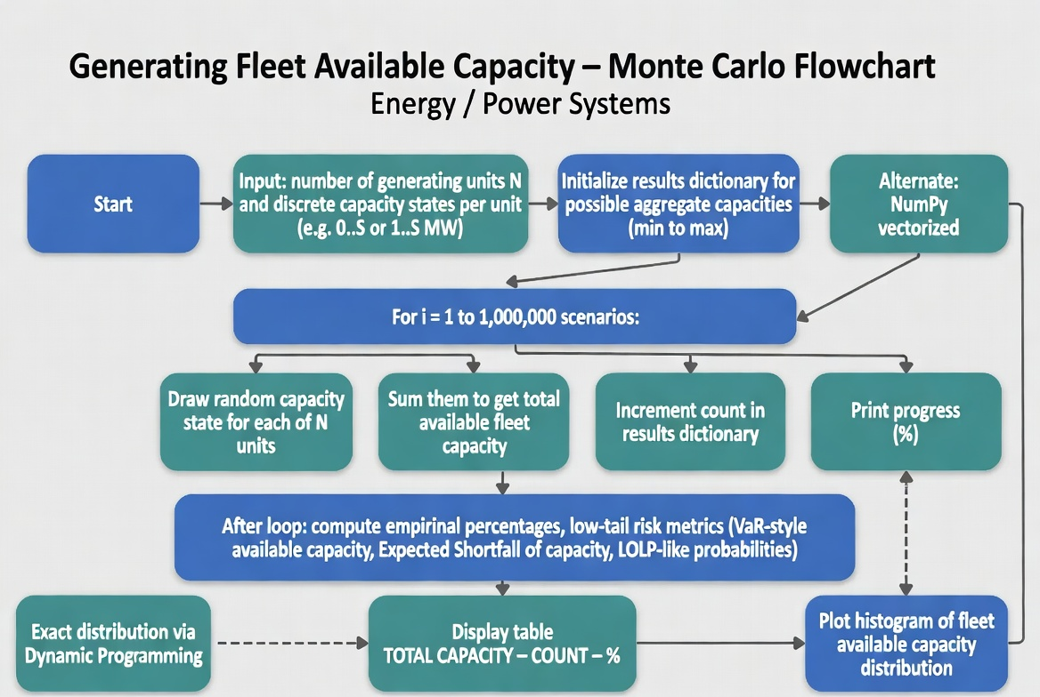
Program flowchart (Monte Carlo path + alternates)
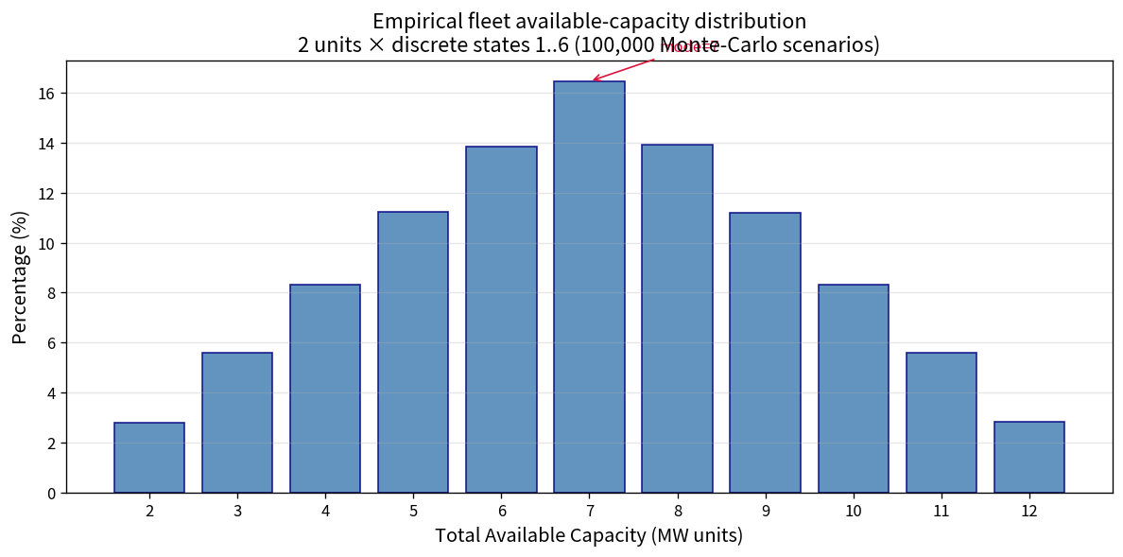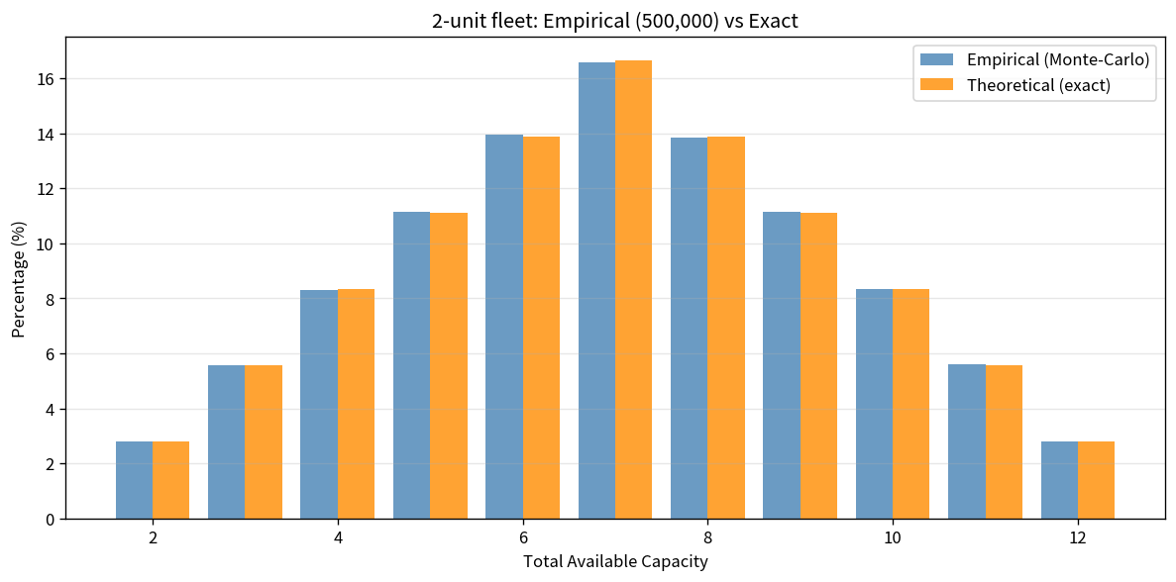
Left: empirical 2-unit histogram | Right: empirical vs exact probabilities
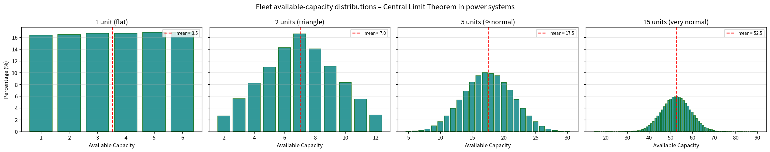
Parameter sweep: 1 → 15 independent units – Central Limit Theorem in power-system reliability

Key Takeaways
• Monte Carlo is the industrial standard for the distribution of available capacity of a generating fleet with discrete (or discretised) unit states.
• Low-tail metrics (Capacity VaR, Expected Shortfall of capacity, LOLP-style probabilities) are obtained directly from the ordered simulated scenarios.
• The Central Limit Theorem explains why large fleets of independent units produce approximately normal available-capacity distributions, justifying many analytic approximations.
• Vectorized (NumPy) implementations turn a pedagogical loop into production-speed code used in real reliability engines.
• Always benchmark Monte-Carlo results against an exact DP solution for small fleets; the discrepancy quantifies sampling error.
Deliverables: Practice_Skeleton.ipynb • Solution.ipynb • flowchart & analysis PNGs • this 1-page report.

